**MD Sirajul islam** 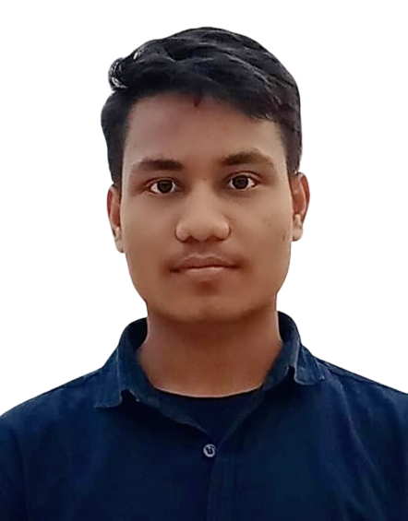

Address: 2nd Raikhali union, Chandroguna, Kaptai,Rangamati.

Mobile No: 01629-744516,

E-mail: sirajul4516@gmail.com

| **Career Objective** |
| --- |

Build up a career as a Nurse working in a challenging environment with excellent career development prospect, where hard work, strict discipline, good communication skill and creative problem solving are the comer stone of success.

| **Career Summary** |
| --- |

* I have working experience as staff Nurse at Square Hospital Ltd.
* I also have working experience at International Rescue Committee as Nurse COVID–19 Response.

| **Employment History** |
| --- |

1. **Position name:** Senior staff Nurse (January 05 to 2020 – May 31, 2020)**.**

**Company name:** Square Hospital Ltd.

**Company Location**: 18/F Bir uttom Quazi Nurozzaman sarak, west panthpath, Dhaka–1205

**Department:** Intensive Care Unit

**2. Position name:** Nurse (June 10, 2020–February 28, 2020)

**Company Name:** International Rescue Committee

**Company Location:** Sayaman Heritage, Sayaman Road, Baharchara, Cox’s

Bazar.

**Department:** COVID–19 Responce

| **Exam Title** | **Concentration/ Major** | **Institute** | **Result** | **Passing year** | **Duration** |
| --- | --- | --- | --- | --- | --- |
| (HSC) | Business Studies | Karnofuli Govt.College | GPA-  3.17 | 2021 | 2 years |
| (SSC) | Science | Narangiri Govt. High School | GPA-  2.83 | 2019 | 10 years |

| **Training Summery** | | | | | |
| --- | --- | --- | --- | --- | --- |
| **Sl. No** | **Name of the topics** | **Institute** | **Location** | **Year** | **Duration** |
| 01 | Graphic Design | Youth Development Computer Training Centre | Chattogram,Noapara | 2022 | 6 Month |
| 02 | Digital Marketing | Harbour IT | Chattogram, Kajir Dewri. | 2021 | 6 Month |

| **Computer Skills** |
| --- |

**> Office Application : MS Word, MS Execel, MS PowerPoint,**

**> Graphic Design : Adobe Illustrator, Adobe Photoshop,**

**> Internet : Able to operate all functions of Internet.**

**> Typing : English And Bengali.**

| **Language Proficiency** |
| --- |

**> English : Good Proficiency in listening, writing, reading and Speaking**

**> Bengali : Good Proficiency in listening, writing, reading and Speaking**

**> Rohingya: Good Proficiency in listening and Speeking.**

| **Personal Details** |
| --- |

**Father’s Name** : Md. Rafiqul Islam

**Mother’s Name** : Sahanu Akter

**Date of Birth** : 13-01-1998

**Gender** : Female

**Marital Status** : Married

**Nationality** : Bangladeshi

**National ID No** : 3753079288

**Religion** : Islam

**Height. :** 5.2"

weigth. : 53 kg

Blood Group. : O+(ve)

BNMC REG No. : 58148

**Permanent Address** : Vill: Lamuchory Para, P.O: Chandragona

P.S: Kaptai, Dist: Rangamati.

**Current Location** : Ukhiya, Cox's Bazar.

| **References** |
| --- |

| Ms. Niru Shamsun Nahar  RN, RM, B.Sc (DU), M.Sc (UK)  Diploma in Advance Nursing (UK)  Principal, GCCN  Phone No: 01727102293  E-mail: [gccn.niru@gmail.com](mailto:gccn.niru@gmail.com) | Khondoker Mahmuda Akter Halim  Rn, RM. B.Sc, MPH (Hospital Management)  Grameen Caledonian College of Nursing (GCCN)  Phone No: 01858085285  E-mail: gccn.mahmuda1@gmail.com |
| --- | --- |

With Best Regards



.............................

Monoara Begum

Date:

